Marsala • Superiore Riserva 10 Years
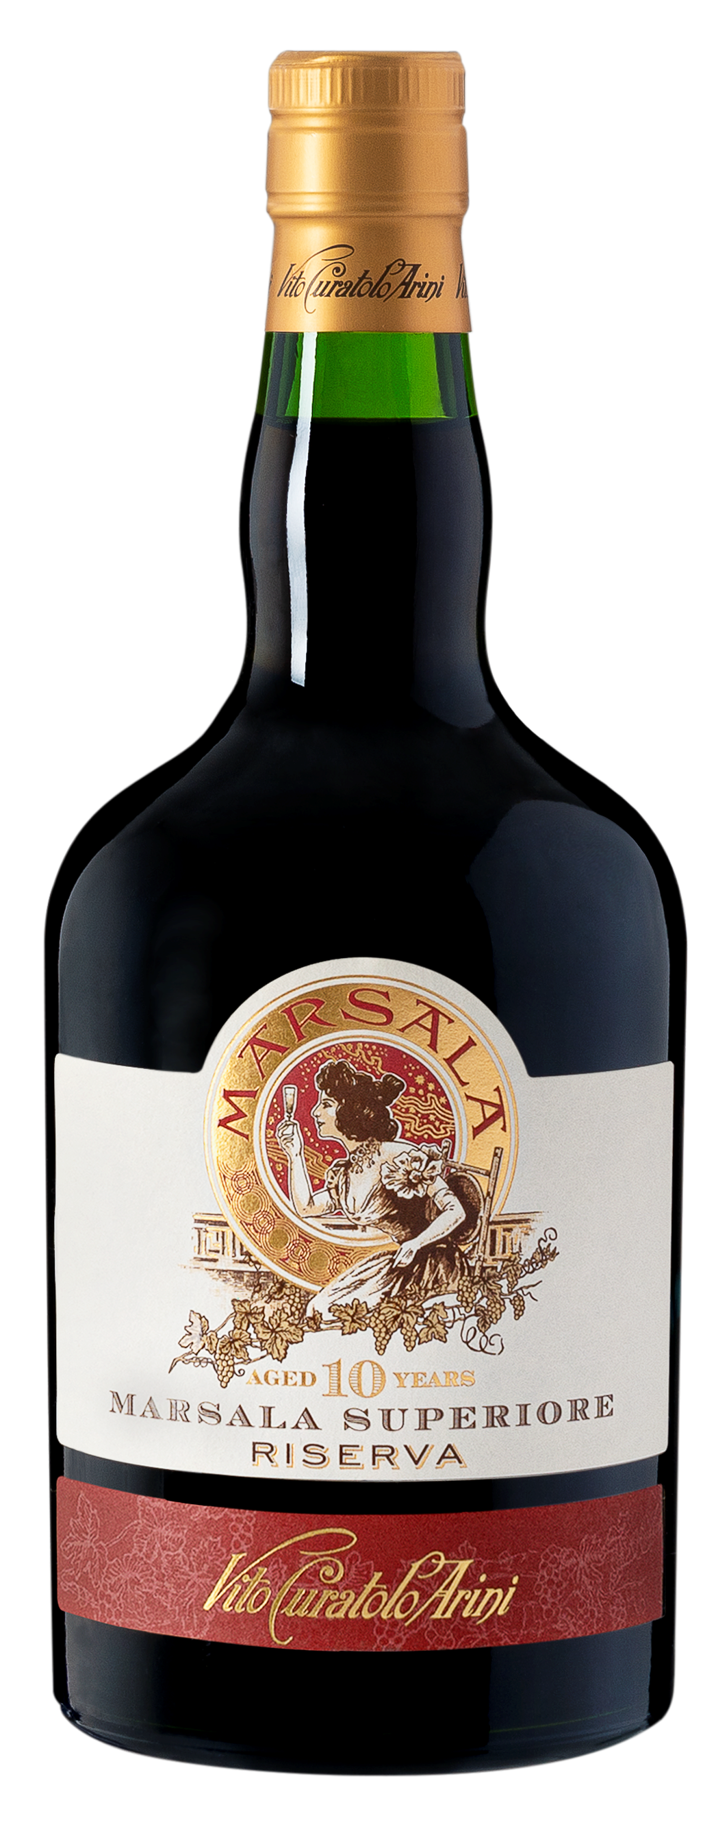
Style
With intense notes of wild almonds, dates, sultanas and vanilla, it is soft and elegant on the palate with a pleasant dried fruit and orange finish. Served slightly cool it is a perfect aperitif and it pairs perfectly with aged pecorino and fig jam, marzipan cakes or dark chocolate desserts
vineyard
Our vineyards are located in the coastal region of Marsala
Winemaking
Destemming, maceration and fermentation at controlled temperature of 20-25C° in stainless steel vats for approx. 7 days with frequent delestages. When all the sugars are developed, skin maceration continues for another 7 days for optimal tannin extraction, very important for the ageing process. Fortification is done adding alcohol up to 18% followed by mistella and cooked must. Ageing in Slavonian casks, French and American barriques and tonneaux

variety | Grillo, Cataratto and Inzolia
region | Contrada Spagnola, Biesina and Baiata, Western Sicily
appearance | Intense gold with shades of Amber
nose | Note of toasted almond, cloves and cinnamon.
palate | Smooth full velvety body of dried fruit with a long lasting elegant spicy finish
maturation & cellaring | Aged for over 10 years in oak barrels
food pairing | One of the best matches is with soft cheese or as an aperitif. Excellent wine even for drinking after meals recommended with fine pastries. Special match is made by our traditional “marzipan fruit”. . Suggested to serve in a medium tulip glass at a slightly cool temperature of 15°C
closure | Natural cork
harvest date | Mid September
bottling date | July 2021
technical info | Alc: 18% TA: 4,2g/l RS: 30g/l pH: 3.4

